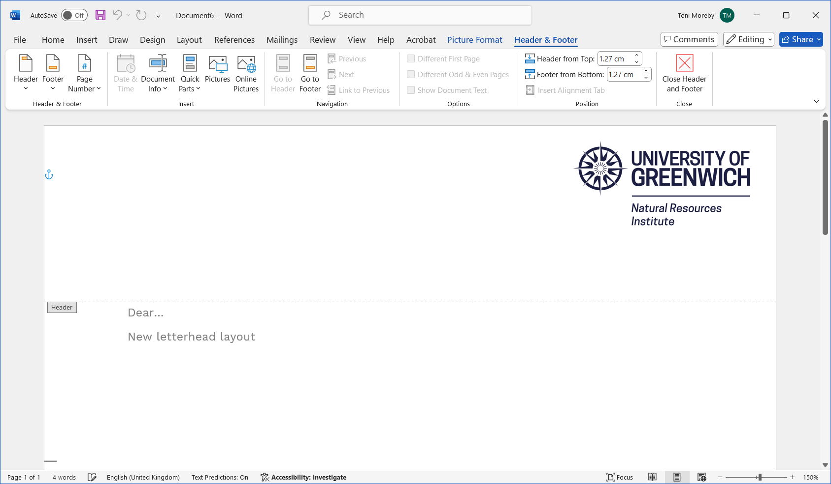

**Participative Soil Carbon Assessment**

**Participant Information Sheet**

# **1. Project Description**

The aim of the project is to test different methods of soil organic carbon assessment, including the self-evaluation kit from Earthwatch, based on the colour of the soil. Soil samples will be sent to a soil lab for standard soil analyses and be analysed at the University of Greenwich using other technologies. Secondary school students in London will also measure soil organic carbon to learn about the technique and its relevance for soil health, farming and climate change. All the data coming from those different analyses will then be compared to assess the robustness of each method and develop a simple method for soil organic carbon assessment.

Funder: Agrifood For Net Zero network (through UKRI), www.agrifood4netzero.net

Lead of the project: Natural Resources Institute at University of Greenwich (Lucie Büchi, Marcos Paradelo Perez, Tuan Nguyen, Gianluca Tozzi)

Research partner: Earthwatch Europe (Peter Hoebe and colleagues)

Education partner: City of London School for Girls (Aman Kanwar)

Farming partner: The Allerton Project (Alastair Leake and colleagues)

Additional stakeholder: Pasture for Life (Nikki Yoxall)

# **2. Nature of Participation and Benefits**

**What do I need to do?**

* Participate in the initial project workshop, where the project team and participating farmers will be able to meet and discuss farmers’ needs and constraints when estimating soil organic carbon in the farm, and how we can address those in the project. This workshop will take place online via Teams, in November or December
* Participate in the online training to use the soil assessment kit and sampling soils for the project. This training will take place online via Teams, in December.
* Take soil samples and do the visual soil assessment in ~5 fields on your farm, and send back the samples and data to the project team. January-February.
* Participate in the closing workshop where the results from the project will be presented and discussed. This workshop will take place online via Teams, in September 2025 (to be discussed).
* *Optional: measure other characteristics of the soil*
* *Optional: participate in a WhatsApp group to exchange information and tips, and get help from the project team.*
* *Optional: repeat the visual assessment later during the year to compare the results.*
* *Optional: participate in an online meeting with secondary students to discuss the challenges of farming and soil carbon.*

**What do I get from it?**

* Data about field soil characteristics coming from the analytical lab and the other methods used to assess the soil, and benchmarking with other participants in the project.
* Direct access to colleagues and researchers to discuss matters related to soil health and carbon.
* Access to the soil health app from Earthwatch for the duration of the project.
* Financial contribution of £100

# **3. Consent and Withdrawal**

Every participant needs to fill in the Consent form before the start of the work. It is the responsibility of the Partner obtaining the consent to submit to the Project Lead.

All data collected will be anonymised before analysis and personal identifiers will not be shared with external parties.

Participants can subsequently withdraw from the project at any time before the end of the project on the 30th of September 2025. Please contact the Project lead at [L.A.Buchi@greenwich.ac.uk](mailto:L.A.Buchi@greenwich.ac.uk) if you wish to withdraw.

# **4. Confidentiality and Data Protection**

Data will be collected through in situ assessment, laboratory analysis, and participative soil assessment. Participants in the citizen science component will submit data through a secure, GDPR-compliant online platform.

Processed data will be stored on a secure University of Greenwich network drive and/or Microsoft 365 environment which both have restricted access to ensure data integrity and security.

Only data essential to the project will be collected, ensuring minimal personal data collection. Informed consent will be obtained from participants, detailing the purpose of the data collection and how their data will be used.

Personal data will be anonymised where possible to protect participant privacy. Access to personal data will be restricted to the project investigators only, who are all trained in GDPR compliance. Participants will be informed of their rights under GDPR, including the right to access their data, rectification, and erasure.

Only aggregated and anonymised data will be published in articles, ensuring no personal data is disclosed. These same data may also be stored in a public repository for research data, in an anonymous form. MSc students from the University of Greenwich may be involved in the processing of the samples and analysis of the data, but will only have access to the anonymised data.

# **5. Ethical Approval**

The management of this project will follow the "Ethics Code of Practice on Research with People” of the University of Greenwich, Natural Resources Institute.

# **6. Project Contacts**

Project lead:   
Lucie Büchi, [L.A.Buchi@greenwich.ac.uk](mailto:L.A.Buchi@greenwich.ac.uk)

Project co-leads:   
Marcos Paradelo Perez, [M.ParadeloPerez@greenwich.ac.uk](mailto:M.ParadeloPerez@greenwich.ac.uk)  
Peter Hoebe: [phoebe@earthwatch.org.uk](mailto:phoebe@earthwatch.org.uk)

**PARTICIPANT CONSENT FORM**

To be completed by the participant.

|  |  |
| --- | --- |
| * I have read the information sheet about this study * I have had an opportunity to ask questions and discuss this study * I have received satisfactory answers to all my questions * I have received enough information about this study * I understand that I am free to withdraw from this study:   + Until the end of the project on the 30th of September 2025   + Without giving a reason for withdrawing * I agree to take part in this study   I wish to be included in the WhatsApp group for this project, please tick here  We may wish to use your research data for a further project in anonymous form. If you agree to this, please tick here | |
| Signature of participant: | Date: |
| Participant name in block letters: | |
| Participant address (for shipping of the soil health kit): | |
| Participant phone number if participating in the WhatsApp group: | |